THERMAL FRONT DYNAMICS IN THE MAURITANIAN ZEE DURING 2018
By: Bambaye Hamady & Dia Abdou

The south Atlantic water bodies which have a vertical layer of 30 to 40 m coming from the equatorial counter current, sometimes called Guinean waters, reach their northern border (20°50’N) during the hot season. These waters are hot (26.8 - 28.8°C) and relatively less salty (34.00 - 35.5 psu) because of the flow of African continental waters (Debravolskya 1964 ; Manriques and Fraga 1982). They alternate seasonally with the North Atlantic surface water bodies, which occupy the northern part of the region and a layer from the surface to depths of 100 to 150m (to 100 - 150m deep). These water bodies are formed by the southern branch of the Canary current. They undergo considerable special transformations which are conditioned by the influence of the atmosphere. They are characterized by cold waters (16 - 24°C) and relatively salty (35.9 - 36.70 psu; Fraga F. 1973).
The meeting between these two water bodies creates a third water body with its own characteristics, called the thermal front. This front is characterized by temperatures that vary between 22 and 24°C. It is conducive to the reproduction of different species of fish, and for this reason it plays a vital role on productivity. The seasonal alternation of these water bodies causes seasonal dynamics of the thermal front from south to north and vice versa. And the displacement of this front motivates a seasonal migration of certain pelagic species.
The present work aims to follow the movement of the thermal front, during the year 2018, determined the period of entry and exit of this front in the Mauritanian EEZ, as well as its stay.

MATERIALS AND METHODS

The data used for this work are weekly averages of surface temperature (sst) during the year 2018.
This data is derived from the real-time marine database of the United States National Center for Environmental Prediction (NCEP). This base contains monthly averages of different hydrometeorological parameter in present time.
The information is gathered at NOAA from various sources, and NOAA aggregates it under monthly averages at one-square-degree resolution.
The information meets at NOAA from various sources and groups it under monthly averages at a resolution of one square of one degree.
Water temperatures varying between (22°C) and (24 ° C) are taken as indicators of the presence of thermal front waters.
Water temperatures ranging between 22 ° C and 24 ° C are taken as indicators of the presence of thermal front waters.
The data processing was carried out using the FoxPro9 software and the mapping using the software Surfer12.
The study area (Figure 1) covers the NWA coast from Cape Verde to Cape Boujdour (15 ° N _ 27 ° N).

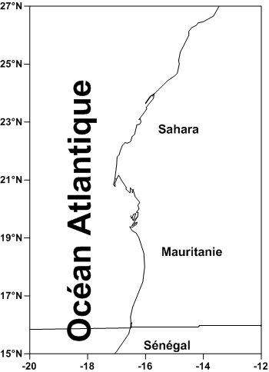
Figure1 : study area

RESULTS AND DISCUSSIONS

Usually the waters of the thermal front begin to penetrate the Mauritanian areas at the end of the last week of May, and retreat towards the end of the last week of December, with an average stay of 178 days.
The movement of the thermal front during the year 2018 was characterized by late entry (Figure 2), around the third week of June. The thermal front followed its displacement in the Mauritanian EEZ where it stayed for one month and three weeks, reaching the northern limits of the country (Figure 3) around the second week of August.

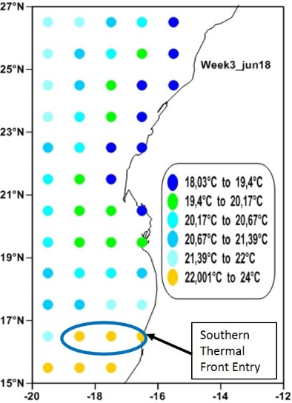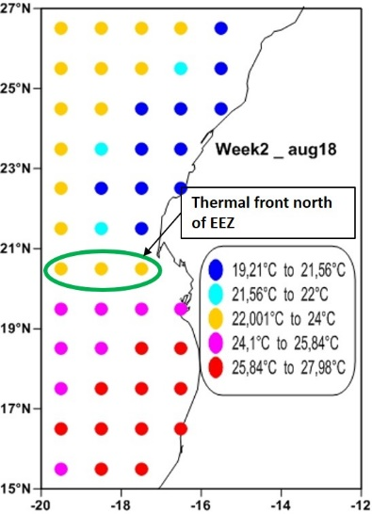
Figure2: Southern thermal front entry Figure3: Thermal front north of EEZ

Le front thermique à quitter les eaux mauritaniennes vers la zone sud du Sahara Occidentale (figure4), à la troisième semaine du mois d’août.

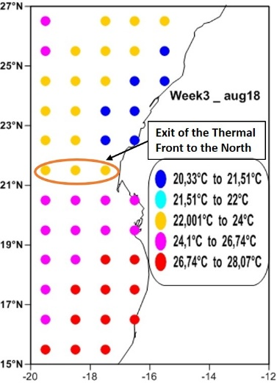 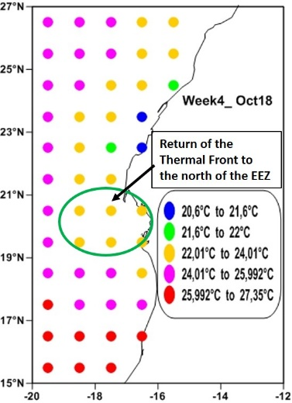 Figure4: Exit of the thermal front to the north Figure5: Return thermal front to the north of EEZ

During this time the waters of the Mauritanian coasts are dominated by warm waters called Guinean waters.
The return of the thermal front to the northern coast of Mauritania was observed around the fourth week of October. The thermal front stayed in the Saharan coast for about two months and a week.
To reach the southern limits of the Mauritanian zone the front lasted two months three weeks. Around January 2019, it totally left Mauritanian waters to Senegal.

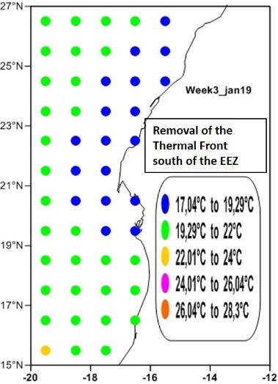
Figure6: Removal of the thermal front south of the EEZ

Figure 7 summarizes the dynamics of the thermal front in the Mauritanian zone. During the year 2018, the thermal front stayed in the Mauritanian coast about 158 ​​days in total.

Months  Lat(°N) | Jun_18 |  |  |  | Aug_18 |  |  |  | Oct_18 |  |  |  | Jan_19
 | W1 | W2 | W3 | W4 | W1 | W2 | W3 | W4 | W1 | W2 | W3 | W4 | W1 | W2 | W3 | W4
16°30’N

20°30’N

21°30’N

Figure7: Dynamics of the thermal front in the ZEEM during 2018

The late inflow and outflow of thermal front waters in the Mauritanian EEZ is closely linked to climate change, which is governed by the situation of regional and global hydro-climatic phenomena (seasonal variability in the positioning of action centres, EL Nino, ENSO, EL Nina, NAO,...). This current state can lead to an exceptional situation of the presence and dynamics of fisheries resources.

Conclusion
The following conclusions can be drawn from this study:

- The presence of thermal front water from the third week of June;
- The exit of the thermal front to the north towards the Dakhla area in the third week of August;
- The Mauritanian coast is totally covered by warm waters from the second half of August onwards;
- the return of water from the front to the north of the MTA in the third week of October;
- in January 2019 the waters of the front withdrew from the Mauritanian coasts towards the Senegal zone.

Bibliographie
Debravolskya L. Le répertoire hydrométéorologique des eaux de la côte occidentale de l'Afrique. - Gidrométéozdat, 1964. - 255 p.
Fraga F. 1973 : Océanografia Quimica de la region de afloramiento del noroest de Africa .I.Res.Exp.cient B/O Cornide ,2 :13-52.
Manriquez M., Fraga F. The distribution of water masses in the upwelling region off Northwest Africa in November // Rapp. P.-v. Reun. Cons. int. Explor. Mer, 180. – 1982. – P. 39-47.
Sites internet consultés :
National Center for Environmental Prediction:
http://ingrid.ldgo.columbia.edu/SOURCES/.IGOSS/.nmc/.Reyn_SmithOIv2/.monthly/.sst/).

Translated with www.DeepL.com/Translator

