1st GMES and Africa Forum
Libreville, Gabon
19-23 November 2018
NAfcoast is represented in the 1st GMES and Africa Forum by Prof. Islam Abou El-Magd from NARSS, Egypt; Prof. Kamal Labbassi from UCD, morocco and Eng. Ahmed Osman from Cartologic, Egypt.
Prof. Islam Abou El-Magd has attended the 1st GMES and Africa Forum representing the North Africa Consortia. The forum was a big gathering of all the GMES and Africa funded projects along Africa to present their status co of the project and to share ideas, thoughts for cooperation. North Africa region is represented by NARSS consortia for Coastal and Marine as well as OSS project for land and water.
Prof. Islam Provided a presentation on the status of the project and sharing the outcomes of the kick off meeting with the immediate/short term project plan for the next few months including the data preparation, methodology and models adoption. The presentation also showed some data preparation for the services and products anticipated from the project. There was also a plan to make sharing and coordination with OSS project for maximizing the value of the 2 projects in North Africa.
There was also a booth with some flyers and posters about the project, which has been presented to the Gabonese minster of science and technology as well as the commissioner of the human resources, science and technology for the African union commission.
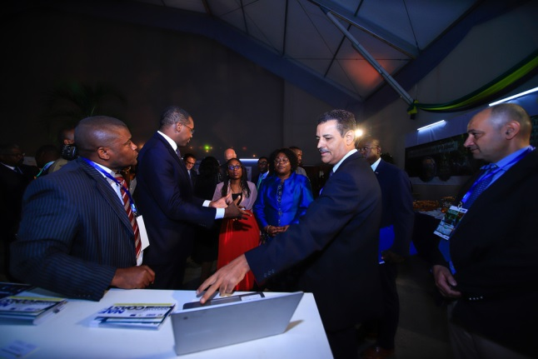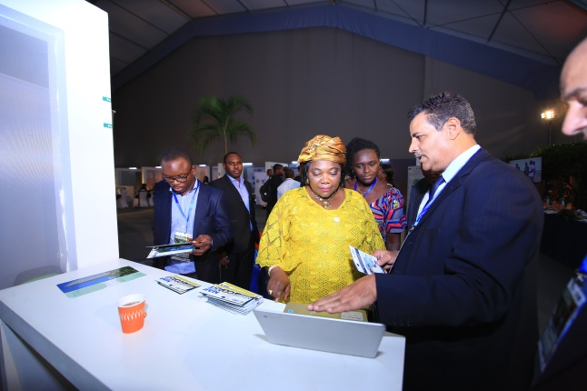

Prof. Islam has proved a key note speech on the blue economy and the data required for the blue economy resources exploitation in Africa. He has also chaired one technical session for the southern region for SADC project and SASCAL project.
