TITLE: NARSS participation in 1st GMES and AFRICA FORUM
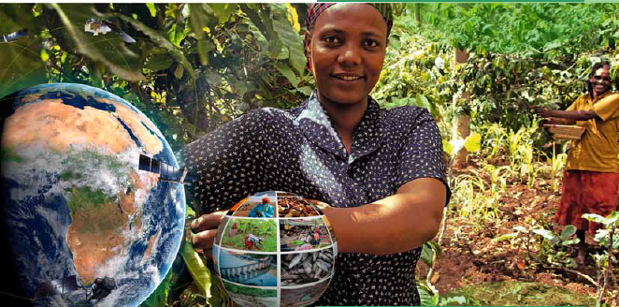

The first GMES AND Africa took place in Libreville, GABON 19-23/11/2018. This conference marks a very important milestone for the GMES and AFRICA community. All project participants from all regions of Africa have gathered for this conference organized by the African Union GMES and Africa program.
The conference outlined GMES and Africa Thematic Services and Priorities for all current projects. Topics for African Environment, Water and Natural Resources, Climate Change, Coastal Economy, Marine and Earth Sciences in relation to Earth Observation were actively presented and discussed.
The main topics of the conference were: Service Development and Delivery, Data and Infrastructure, Training, Research and Development in GMES and Africa and Resource Mobilization, Collaborations and Partnership.
Objectives of the Forum and Expectations, GMES & Africa Coordinator by were greatly presented by Dr. Tidiane Ouattara, GMES & Africa Programme Coordinator, AUC
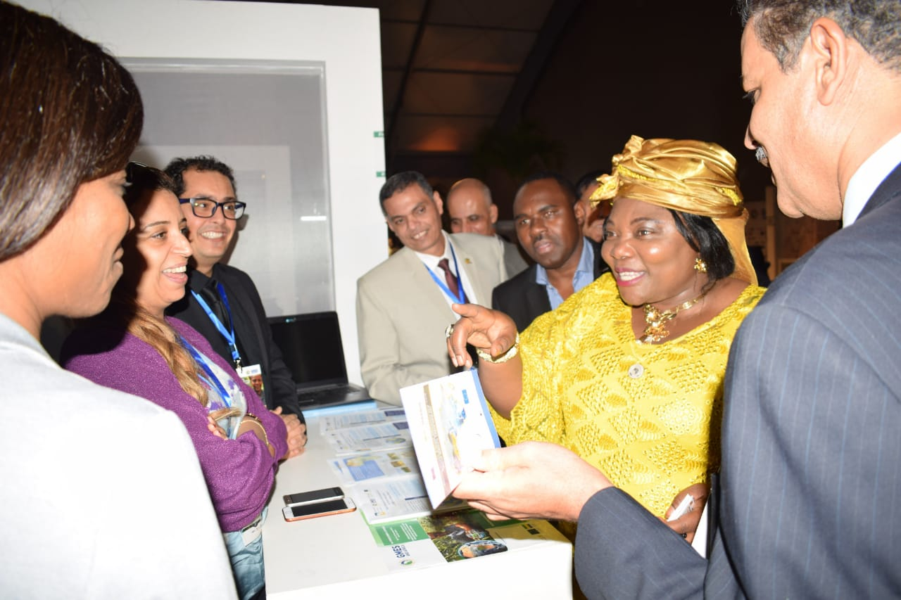The conference featured very inspiring presentations from various project participants. The conference was a great opportunity for project consortiums to review each other work and discuss many areas of interest between projects.
In addition to presentations and panels for each specific projects. The conference featured some outstanding presentations from experts on remote sensing from all over the world. Most inspiring was the presentation from Governor DR. WILBER OTTICHILO about the role of GIS in politics. Which is a great example on how to leverage GIS power to provide better decision making for high ranking government officials. Another great presentation by Athina Trakkas from OGC about the role of standards in providing best service development and delivery.
NARSS consortium provided the road plan presentation for the NAFCOAST project by Dr. Islam Hamza AboulMagd. NARSS reviewed their work with other consortiums discussing areas of interest and cooperation.

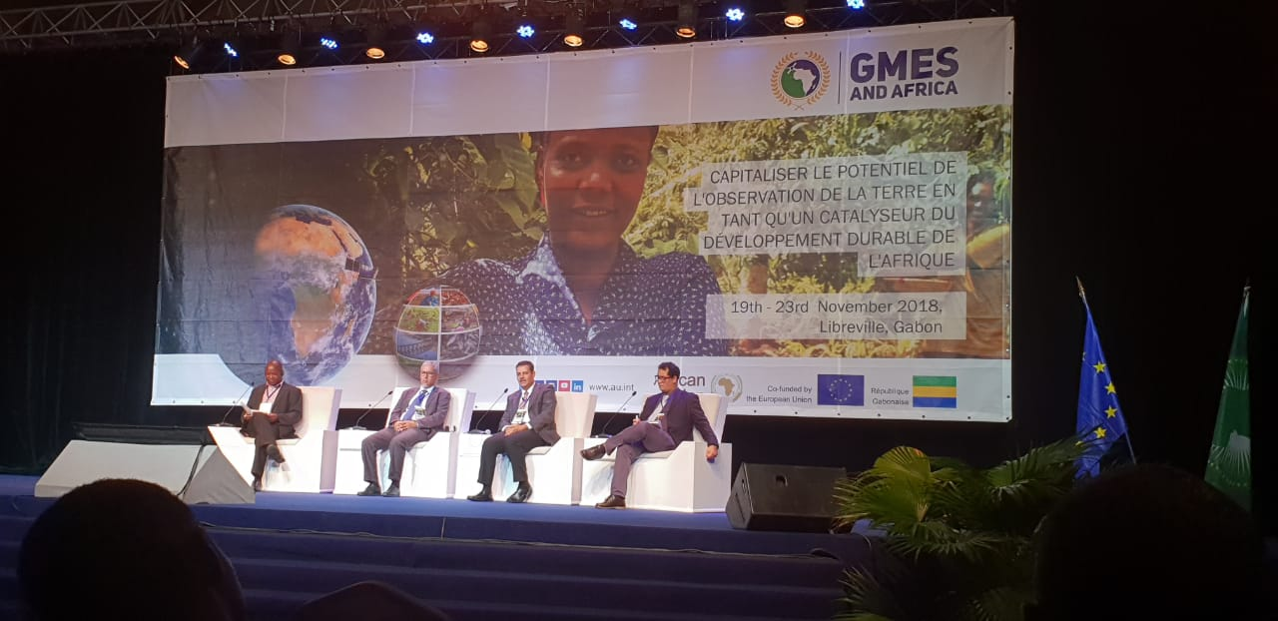
Dr Islam presenting the growth of the blue economy in Africa
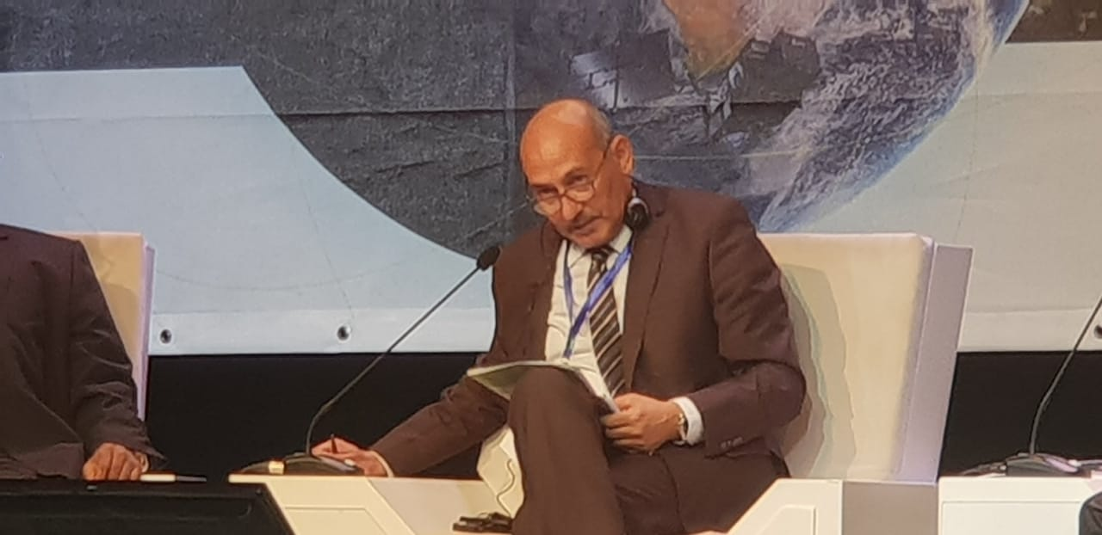
Dr. Kamal Labbasi President of AARSE African Association of Remote Sensing and Environment chairing the session for Earth Observation, Training, Research and Development in Africa
image.png

Overall this Forum is a great start for the GMES and AFRICA program and marks the launch of all work. We wish all participants and GMES and AFRICA all the success in the implementation of their work.

